**Simplilearn Phase Two Project**

**FlyAway (An Airline Booking Portal).**

This project is developed by Badri Logaram

**Core Concepts: Technologies used**

* JSP – used to display front end of pages
* Java- used to write functionality
* JDBC- used to link with database
* MySQL Database- used to store user, flight and admin details.
* Tomcat -9 Server Maven Project is created and respective dependencies are added. RequestDispatcher is used to navigate between servlets or html pages.

**Database Name: Flyaway**

* Schemas in “Flyaway” database are as follows:
* Flights - to store flight details
* Admins- to store admin details
* Users- to store registered user details All exceptions are handled successfully in project.

**Approach for the FlyAway application**

**Phase 1:** Create new project in Eclipse

* Open Eclipse.
* Go to File -> New -> Project -> Maven Project
* Type the project name and click on finish.

**Phase 2:** Welcome screen of the application

* This is the entry point of the application which has the details to search the flight

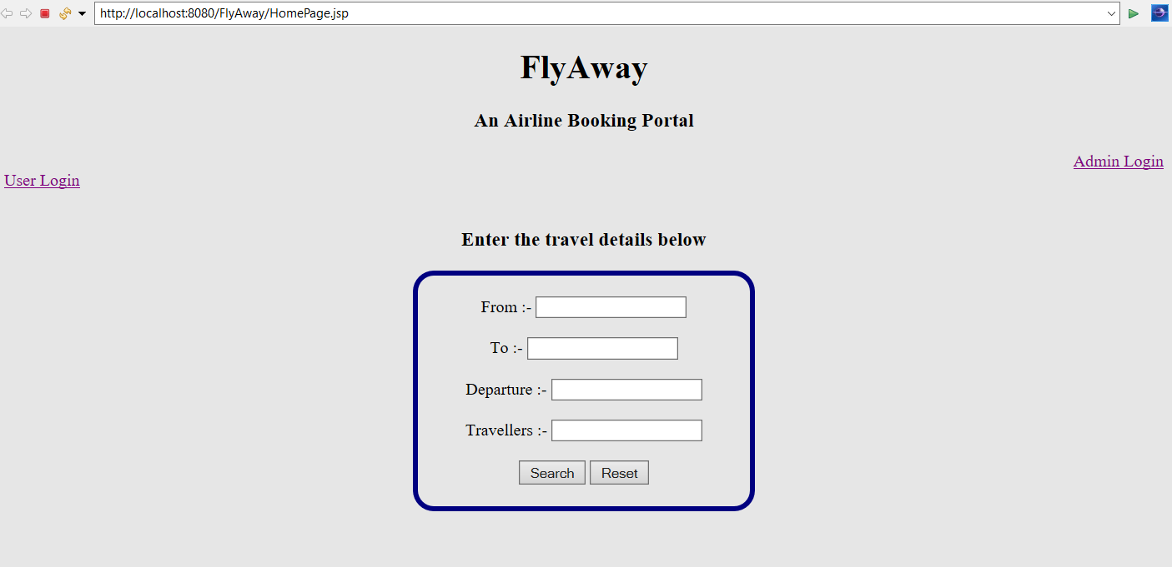

* Enter the details to search the available flights.

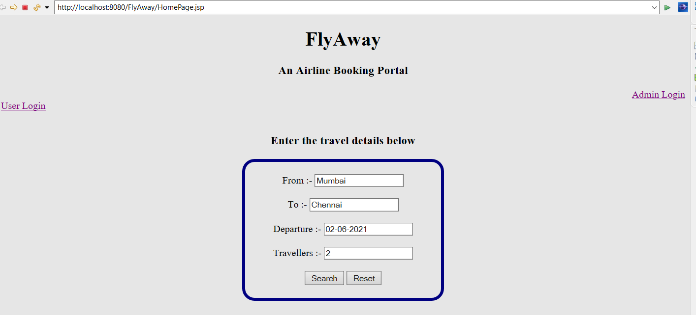

* Once click on submit, shows the list of flights available as per the search results.

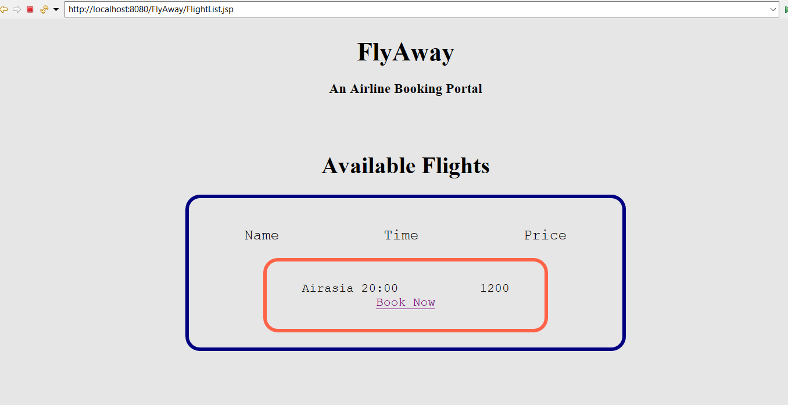

**Phase 3: Login Page**

**User Login**

The user login has two options, where the existing user can login and book tickets and the new user can register for logging in.

**New user**

* Once the user clicks on create account the user is redirected to the registration page.

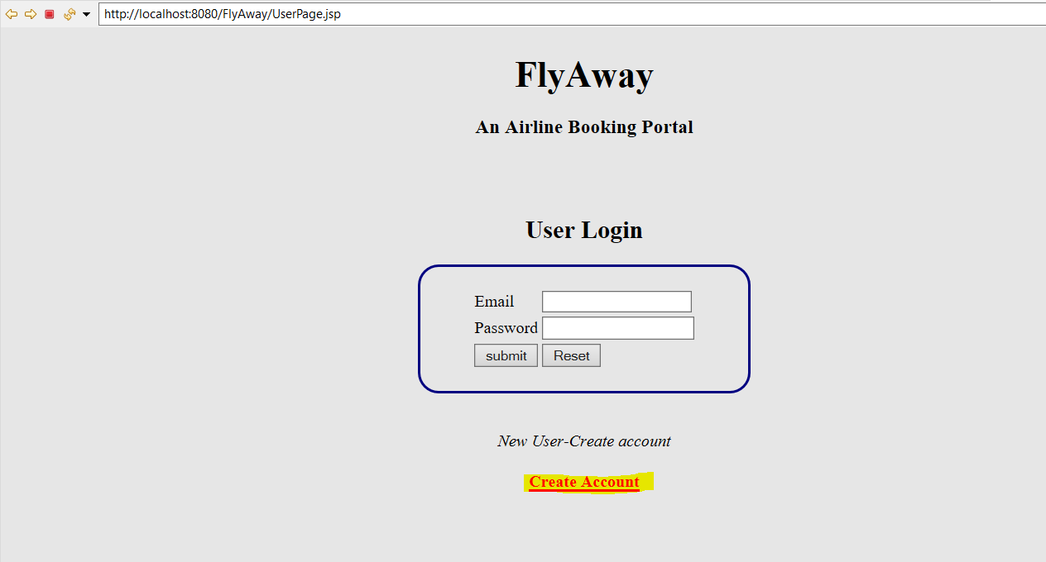

* Now the User can register with the requested details

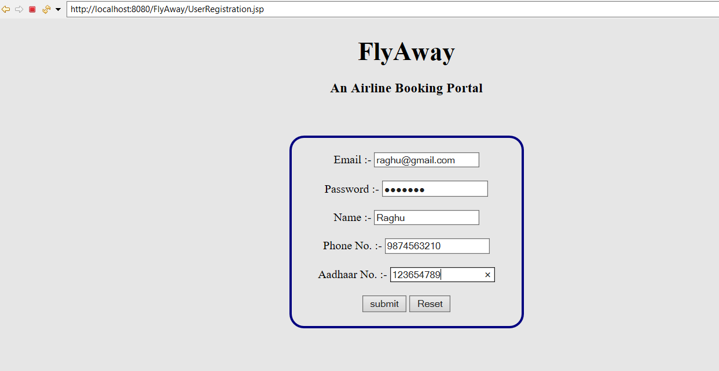

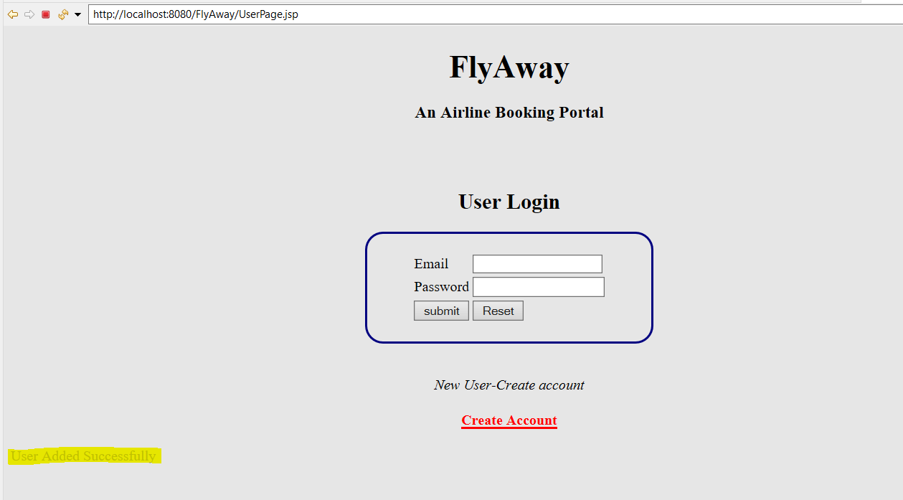

**Existing User**

* The existing user can login directly and book the flight.

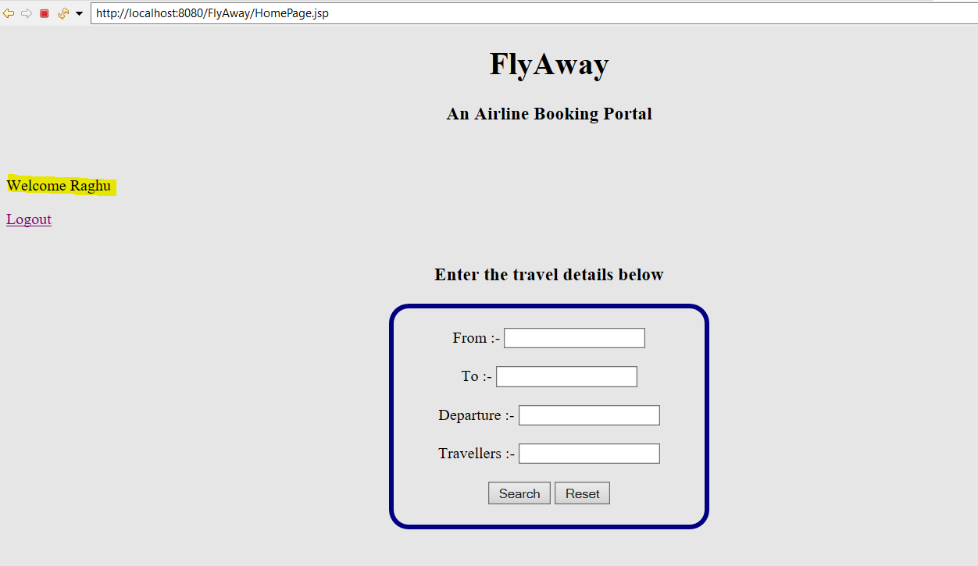

* Master list of flights will be available as per the search.

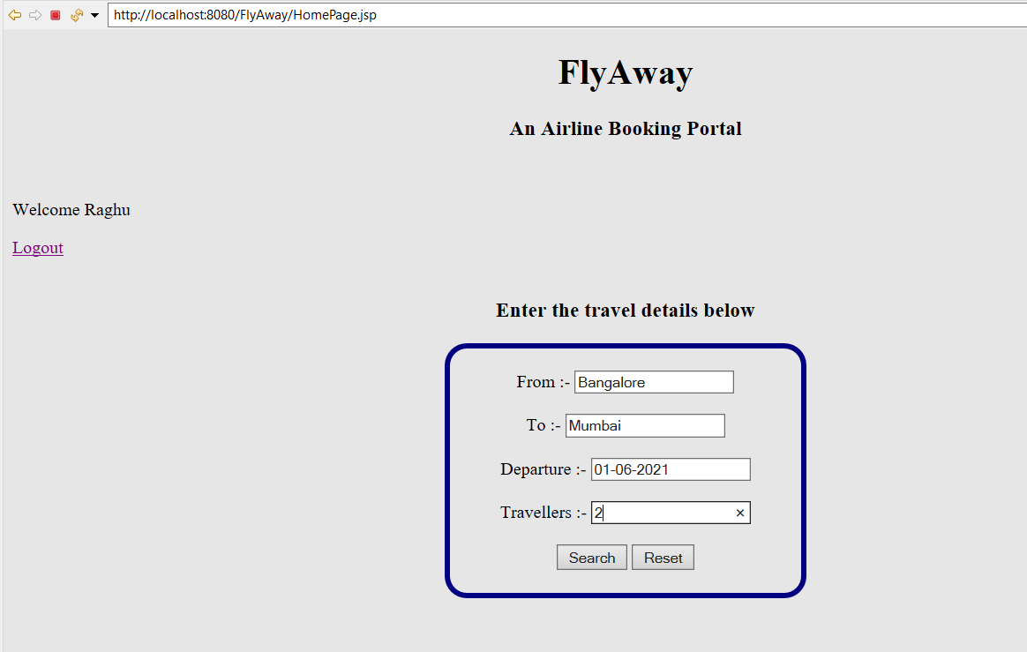

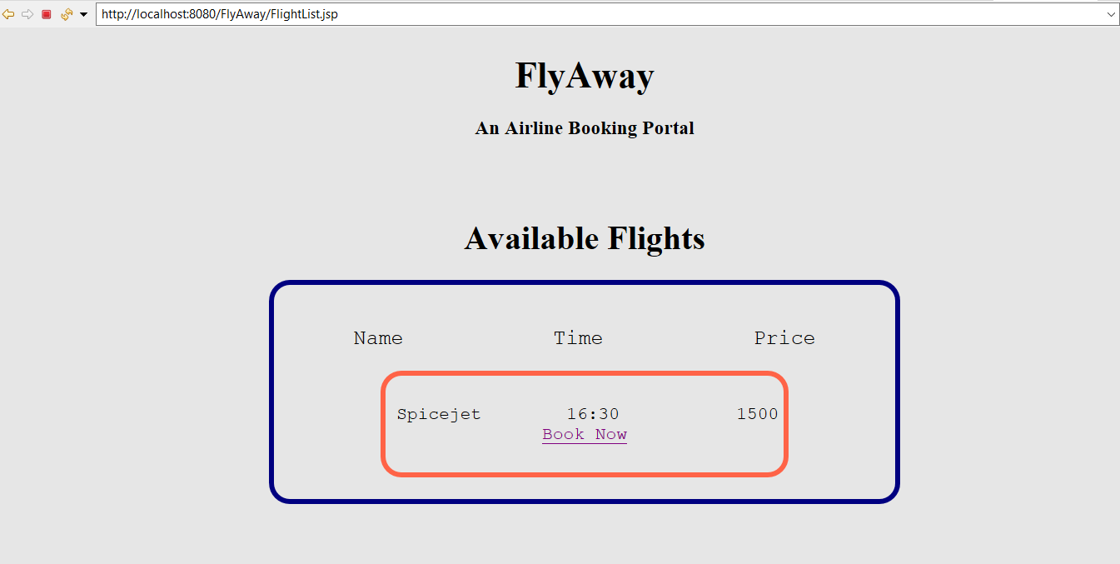

* By clicking on Book now option, the ticket will be booked.

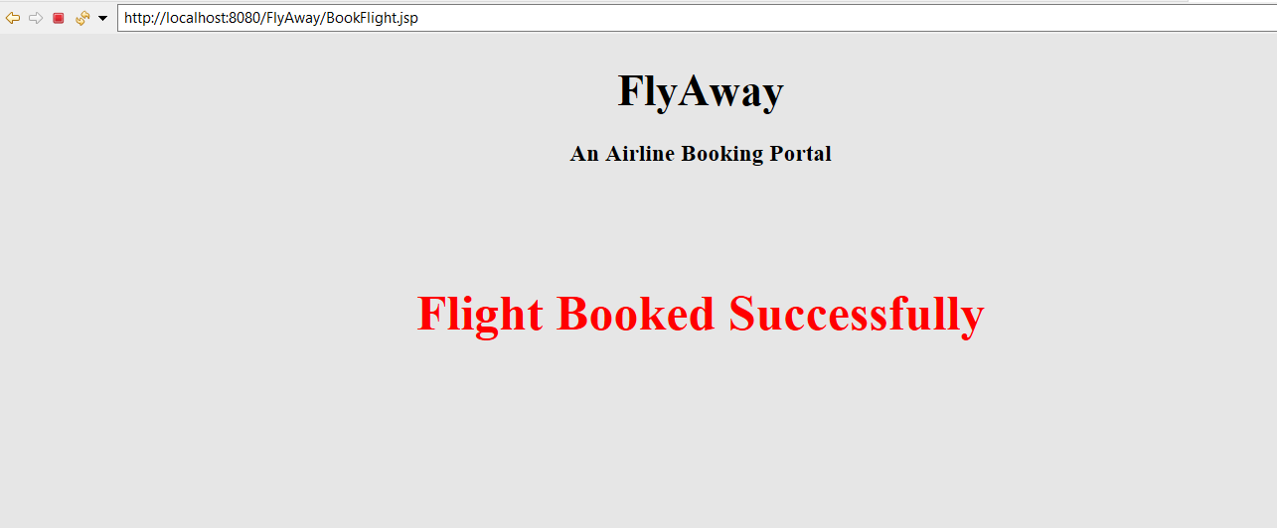

**Admin Login**

* The admin can submit the flight details of the upcoming trip.

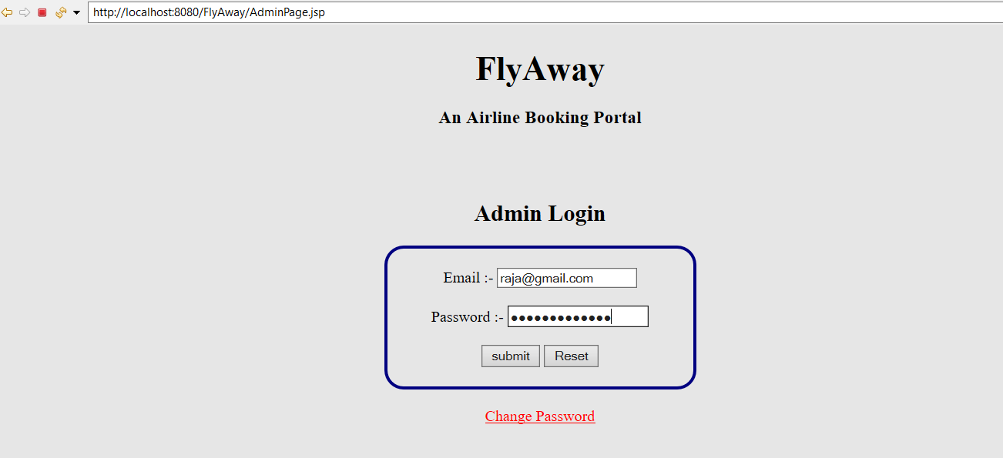

* Enter the flight details and submit

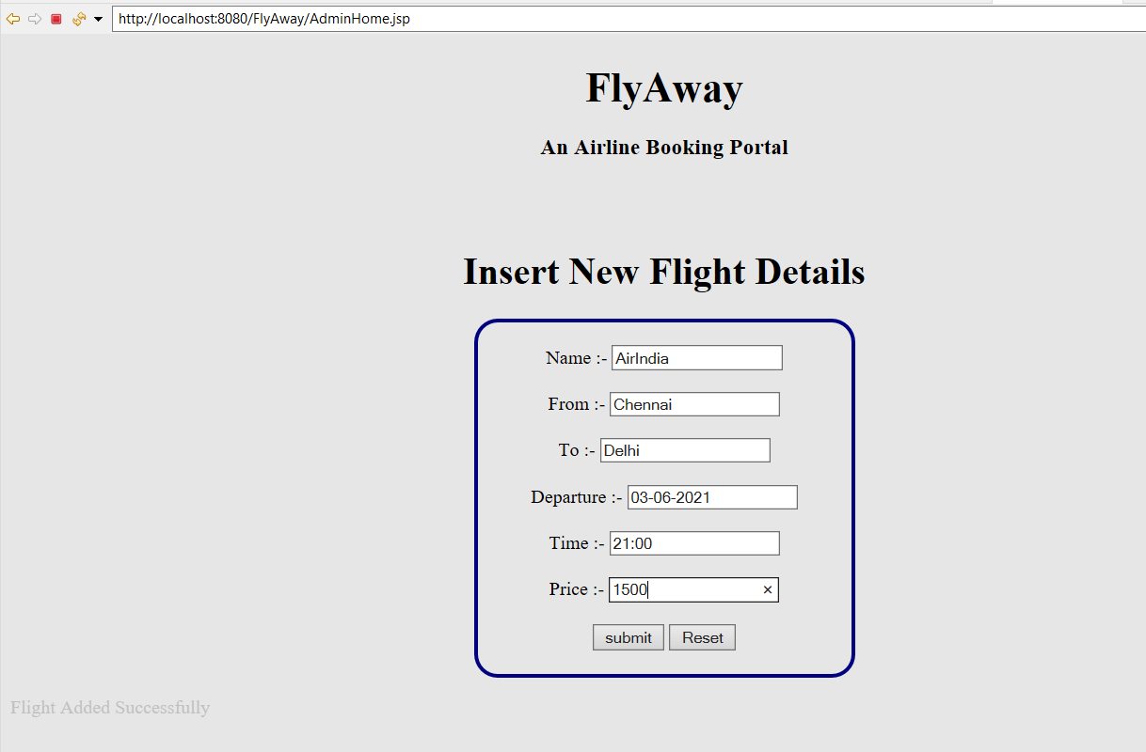

* The admin can also change the password if necessary, which is available in home page of the admin login.

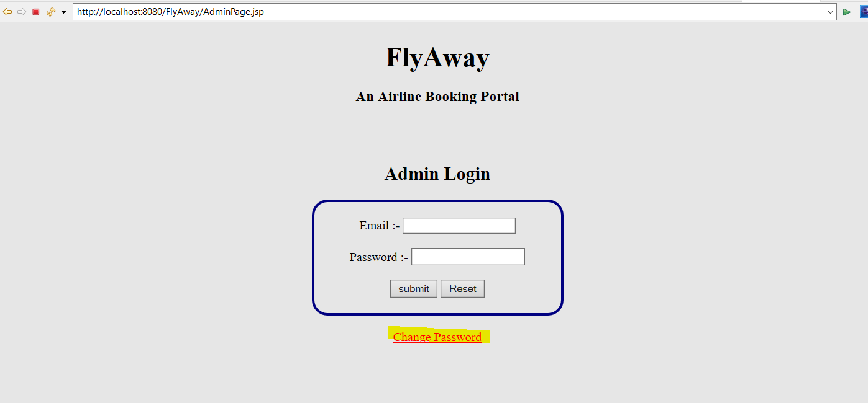

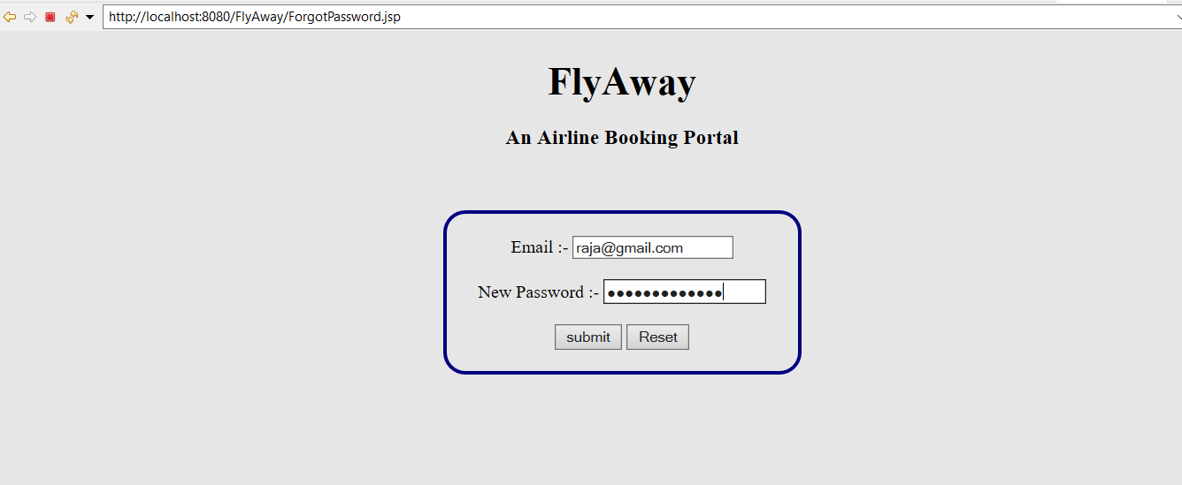

* Once the admin clicks on submit, the password is updated

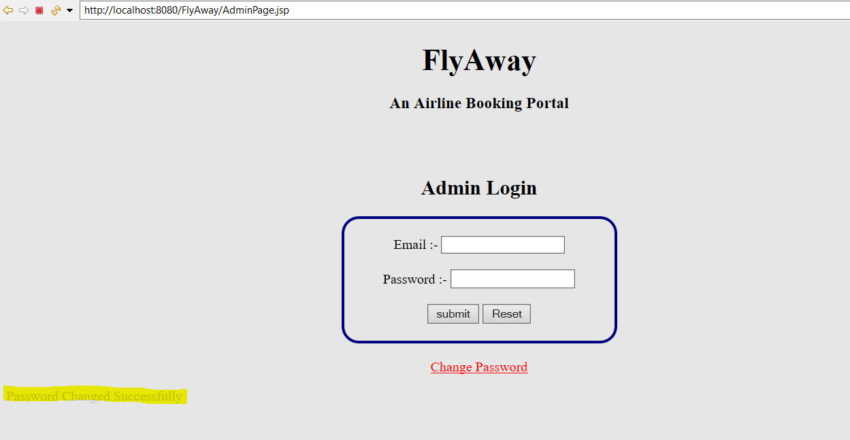

**GitHub Repository:**

**The code repository for this project is available at GitHub:** [**https://github.com/badrilogaram/Phase-One-Project**](https://github.com/badrilogaram/Phase-One-Project)